Assignment submission guidelines (C++)

* Before working you your homework assignments make sure you download the compiler according to these [instructions](https://dl.dropbox.com/u/99030157/pacfiles/cppcompiler.html). Also, run the sample program (do notice the use of "pause" statement).
* In your assignments use the suggested function prototypes (when specified). You can use additional functions (for better modularity) if you want to, but you cannot use fewer.
* If a data file is given - use it. If not (and it is needed), make one up. If output file is created by your program, turn it in. If output is based on an input file given as a part of the assignment, input file doesn't need to be turned in. If you made up your own input file, you need to turn it in as well.
* Before coding you have to create a design document. Here is a short excerpt from your book regarding design documentation:

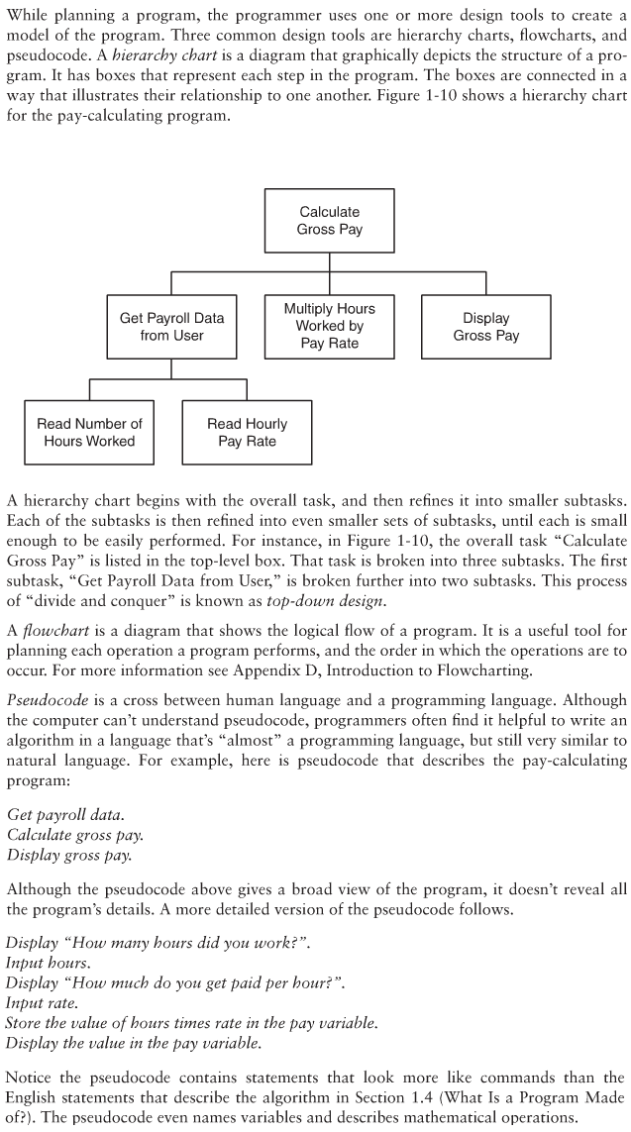

* Use any or all of the design tools described above, or any combination thereof. I am not very strict as far as formatting of such document goes, as long as I can clearly see that you have gone through the 'design phase' prior to starting to write the code. Please note that perfectly looking design doc written after the fact (once your code is already running) is totally useless. For the sake of your future programming career (and sanity!) put your thoughts on paper before writing the code. If your program involves OOP additional design tool to consider is an UML (Unified Modeling Language) diagram. Your book gives you many examples of UML usage.
* a*main.cpp is always going to be your main program name ('*' signifies the program number). If other header files are referenced, you need to use them as specified. For example, do not place your class in the main, if a separate file is required. Do not change the given file or function names. Always turn in your actual source that compiled (i.e. a1main.cpp, not a1main.txt). Do not turn in files that are not required (i.e. .exe).
* Apart from the source code file(s), you will notice that your assignments specify submission of "program compile and run screenshots". Typically there are going to be two screenshots (use Alt-PrtScr to obtain the screenshot. In Win 7 you can also use the snipping tool). The first one will show successful compilation (show as much of your code in the window as possible):

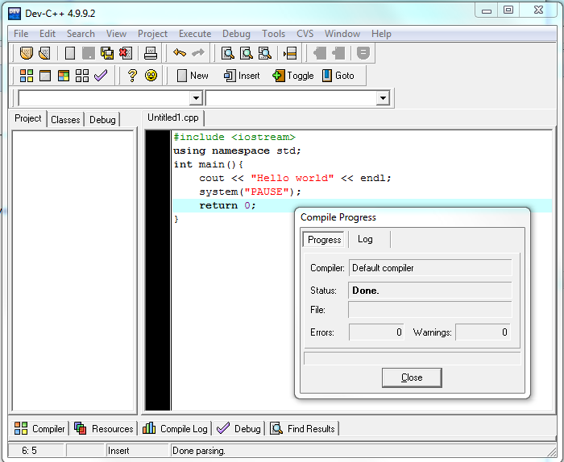

* Note that this is not sufficient proof of compilation, because the reference to original source is not shown:

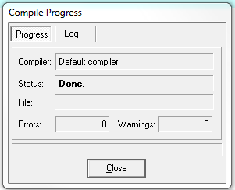

* You will also need to turn in the actual program run screenshot. In the case above, that would be:

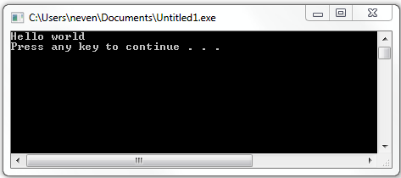

* There might be times when your program output is so long that it will not fit in a single window. In that case, turn in two run screenshots (never more than two; if the output is really long, turn in the first and the last screenshot only).
* Submit all screenshots in a single file (word or pdf). Do not attach images individually. Do not turn images sideways (yes, these are pointers based on my previous experience with submissions). Name your file appropriately (i.e. a1runcompile.doc).
* Do not compress your files. Upload them one by one (with the exception of screenshots - see above). In particular, do not turn in the entire "project" folder. Turn in only the files that are specifically asked for.
* If you use a Mac rather than a PC, you will need to replicate the above in Mac environment. I will not be able to help you with that; however the same type of submitted material is expected, regardless of the environment you use. If you are not working in an IDE (probably not a good idea for most), your compilation command in cmd window needs to be followed immediately by the program run.
* If you ever need to resubmit an assignment, email me as well. Canvas does not notify me of resubmissions.